Latest Numbers - Dec 2007

These are the images of the latest number reports for Meter News 86 – including those that nearly made it!
.

FSC347 Series

Source: AN (MN 86)

FSC907 Series

Source: AN (MN 86)

F04110 Series

Source: AN (MN 86)

FC5110 Series

Source: AN (MN 86)

FJ0710 Series

Source: AN (MN 86)
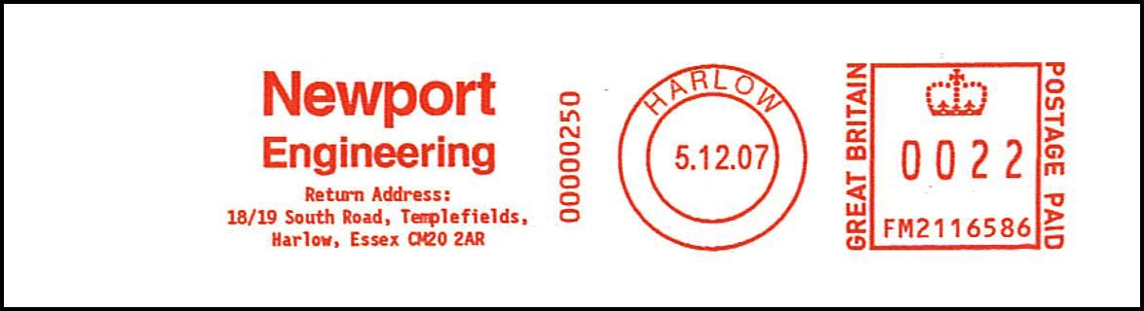
FM2116 Series

Source: AN (MN 86)

FU8002 Series

Source: AN (MN 86)
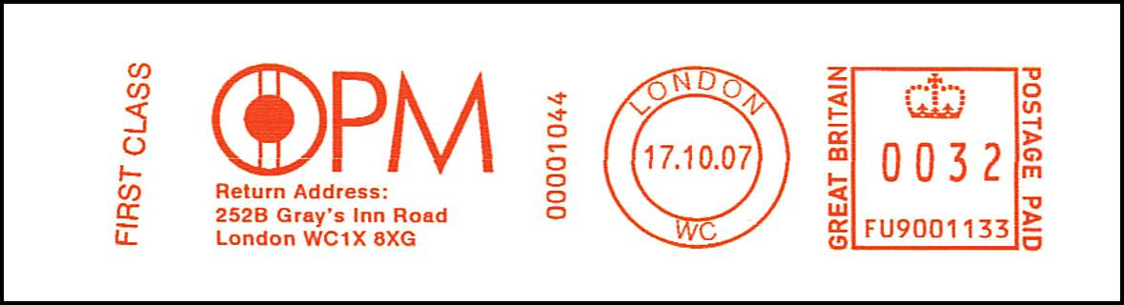
FU9001 Series

Source: AN (MN 86)
N1252 Series
N1252933
12.12.07
London SW1
Image awaited

Source: Peter Mantell (MN 86)
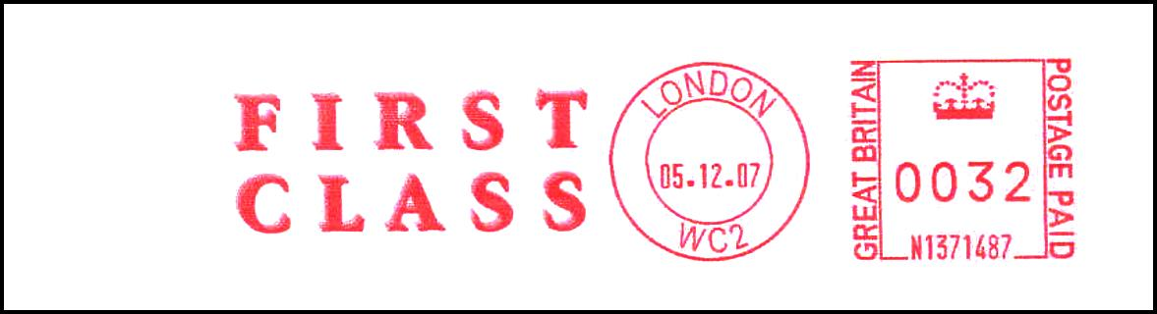
N1371 Series

Source: PM (MN 86)

N1382 Series

Source: AN (MN 86)

PB019 Series

Source: PM (MN 86)
PB277 Series
PB277760
06.11.07
London WC2
No image available

Source: Patrick Awcock (MN 86)

PB483 Series

Source: AN (MN 86)

PB611 Series

Source: AN (MN 86)

PB763 Series

Source: AN (MN 86)

PB833 Series

Source: AN (MN 86)
. . . and those that almost made it:

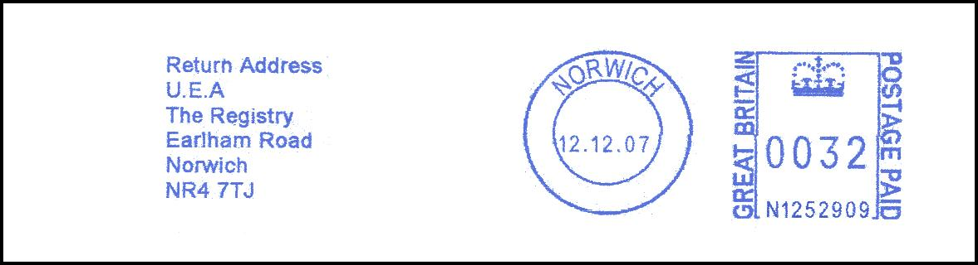
N1252 Series

Source: PR

N1382 Series

Source: AN

N1382 Series

Source: AN

PB276 Series

Source: AN

PB277 Series

Source: AN

PB610 Series

Source: AG

PB611 Series

Source: AN

PB832 Series

Source: PM

PB833 Series

Source: PM

